 **Name**: Adwait Purao

**UID**: 2021300101

**Problem Statement**: To understand the working of an oven using simulation.

| Type / freq-amplit ude (Power) | One Molecule | Single line of molecule | Many Molecule | Coffee |
| --- | --- | --- | --- | --- |
| Low Frequency  , Low Amplitude  (OR)  Power - 25% | The molecule absorbs minimal energy from the microwaves, resulting in a slow or negligible increase in temperature. The low input of energy could lead to a stable temperature for the molecule. (Refer Figure 1.1) | The temperature of the molecules may rise slowly or remain stable due to the low energy input from the microwaves.(Refer Figure 2.1) | Overall, the system of molecules may absorb minimal energy from the microwaves, leading to a slow or negligible increase in the temperature of the system as a whole. The low energy input may result in a relatively stable temperature for the molecules.(Refer Figure 3.1) | The temperature of the molecules within the coffee mug may increase slowly or remain relatively stable. The lower power input results in a gradual rise in temperature, affecting the overall thermal dynamics of the system.(Refer Figure 4.1) |
| High Frequency  , Low Amplitude  (OR)  Power - 50% | The molecule may experience a moderate to rapid rise in temperature due to the higher frequency, even with the low amplitude limiting the overall energy input. This can result in a | The temperature could rise more rapidly compared to the  low-frequency case, although the low amplitude might limit the overall increase in temperature.(Refer Figure 2.2) | The higher frequency may lead to a more rapid temperature increase for the system of molecules, although the low amplitude might limit the overall energy input and consequently the | The molecules trapped in the coffee mug are likely to experience a moderate temperature increase compared to the lower power setting. This intermediate |

|  | noticeable but limited increase in temperature.(Refe r Figure 1.2) |  | extent of temperature rise.(Refer Figure 3.2) | power level contributes to a moderate but noticeable rise in temperature.(Re fer Figure 4.2) |
| --- | --- | --- | --- | --- |
| Low Frequency  , High Amplitude  (OR)  Power - 75% | The low frequency might lead to a slower temperature increase, but the high amplitude could result in significant energy absorption, potentially causing a pronounced rise in temperature for the molecule.(Refer Figure 1.3) | The temperature may rise at a slower rate due to the low frequency, but the high amplitude could lead to significant temperature increases once the energy is absorbed by the molecules.(Refer Figure 2.3) | While the low frequency may result in a slower rate of temperature increase for the molecules, the high amplitude could lead to significant energy absorption across the system, potentially causing a more noticeable rise in temperature.(Ref er Figure 3.3) | At 75% power, the temperature within the coffee mug is expected to rise more rapidly compared to lower power levels. The increased power input accelerates the thermal energy transfer to the molecules, leading to a significant temperature elevation.(Refer Figure 4.3) |
| High Frequency  , High Amplitude  (OR)  Power - 100% | With both parameters at high levels, the molecule may experience the most rapid and pronounced increase in temperature due to the combined significant energy delivery from the microwaves.(Refe r Figure 1.4) | This setting might lead to the most rapid temperature increase, as the higher frequency and larger amplitude could deliver more energy to the molecules, causing a more pronounced rise in temperature.(Refer Figure 2.4) | With both parameters at high levels, the system of molecules may undergo the most rapid and pronounced increase in temperature, as the combined high frequency and amplitude deliver a significant amount of energy to the entire system.(Refer Figure 3.4) | Running the simulation at full power results in the most rapid temperature increase for the molecules trapped inside the coffee mug. The high power setting delivers maximum energy input, causing a substantial and swift rise in temperature within the system.(Refer Figure 4.4) |



# Images :

1. **One Molecule**
   1. **Low Frequency , Low Amplitude**

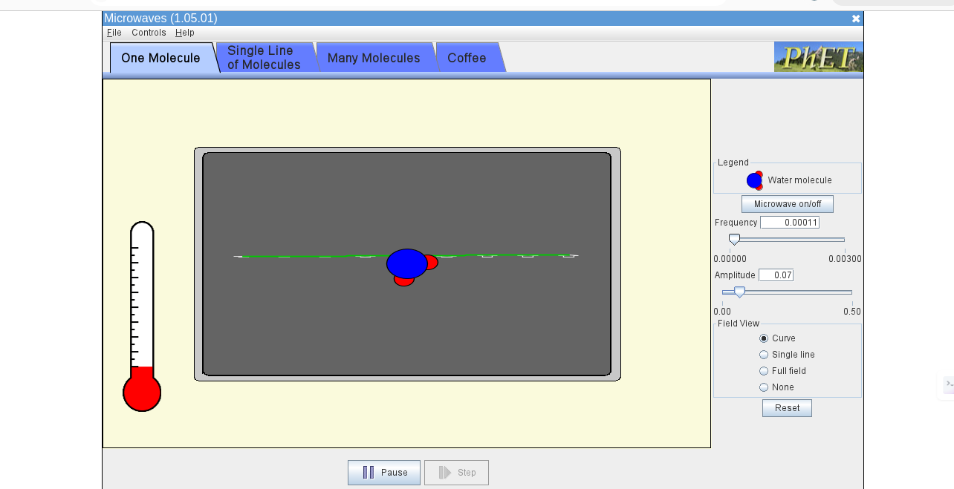

* 1. **High Frequency , Low Amplitude**

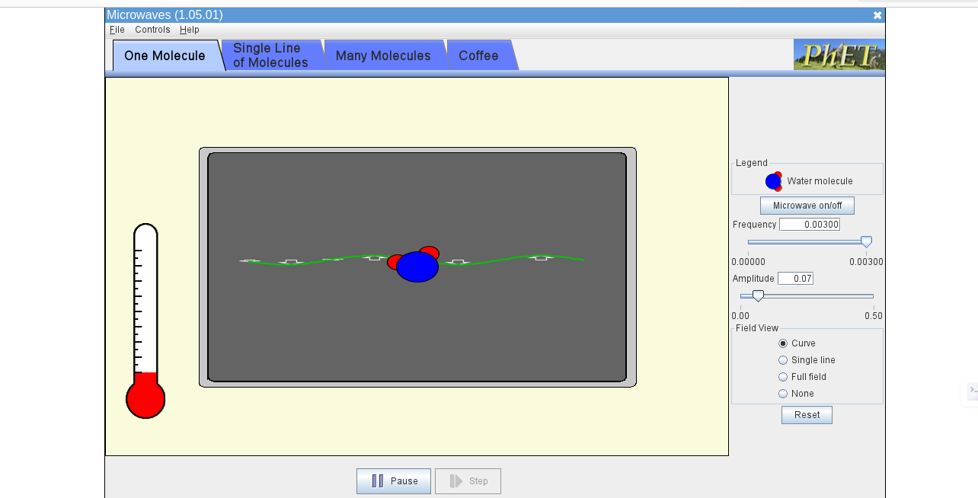

* 1. **Low Frequency , High Amplitude**

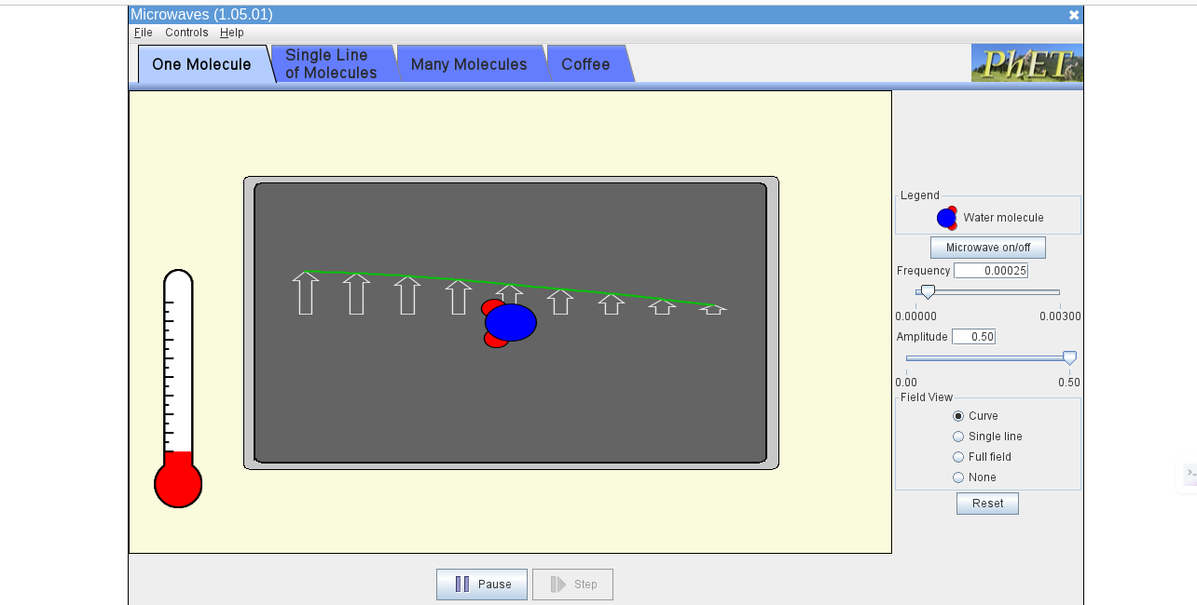

* 1. **High Frequency , High Amplitude**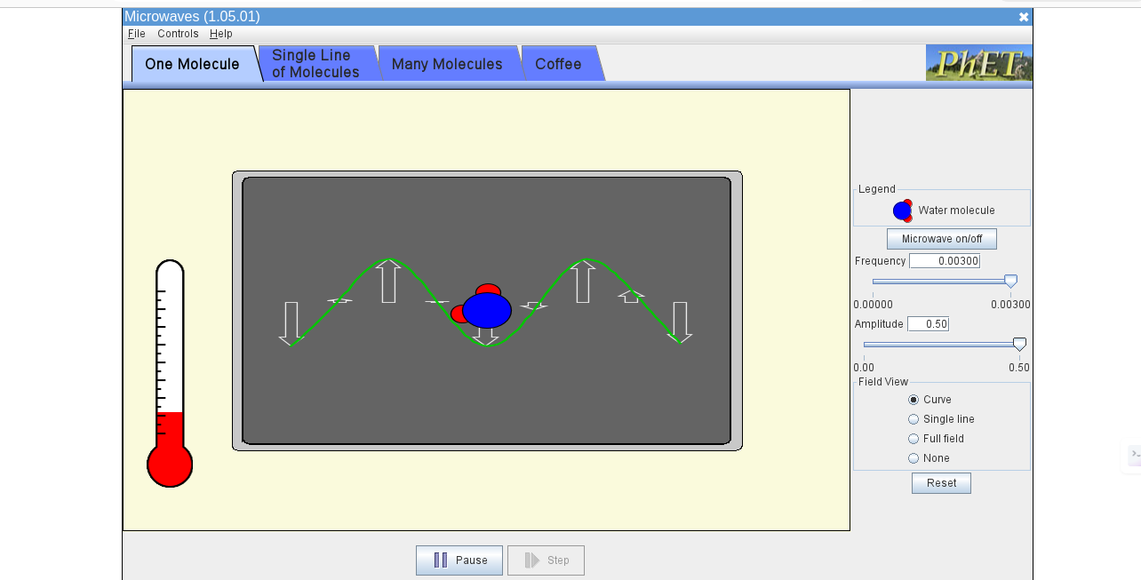

# Single Line of Molecule

* 1. **Low Frequency , Low Amplitude**

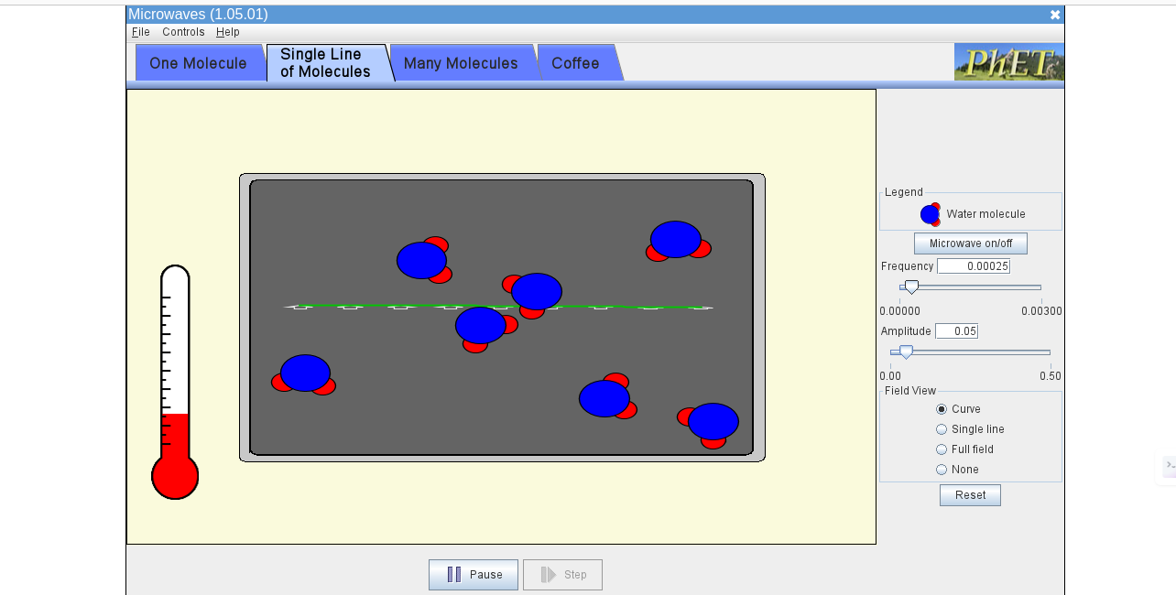

* 1. **High Frequency , Low Amplitude**

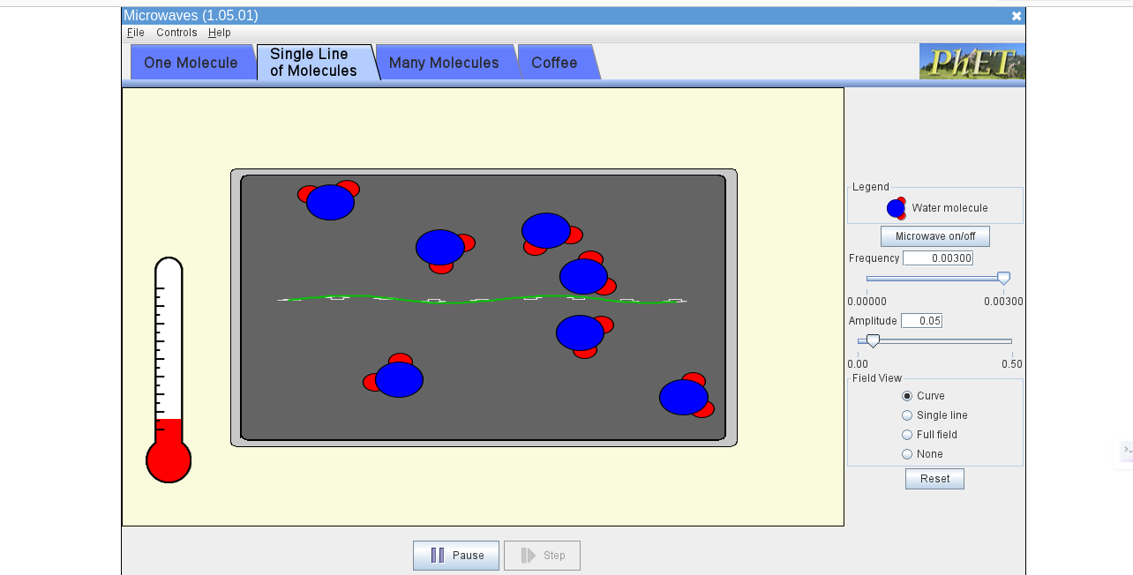

* 1. **Low Frequency , High Amplitude**

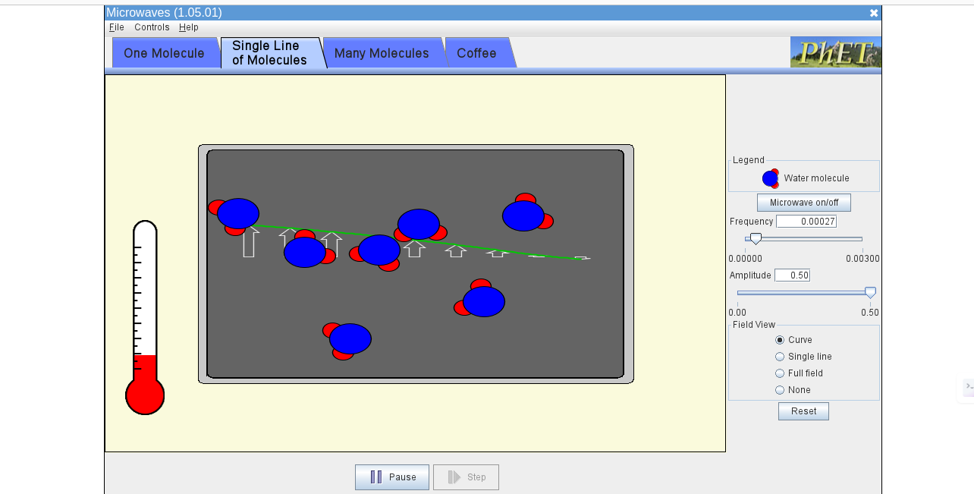

* 1. **High Frequency , High Amplitude**

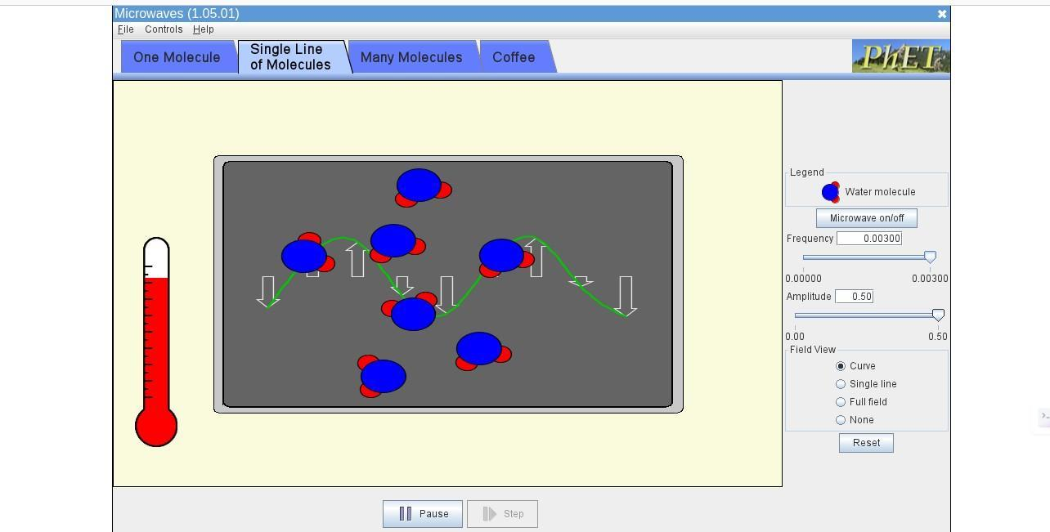

# Many Molecule

* 1. **Low Frequency , Low Amplitude**

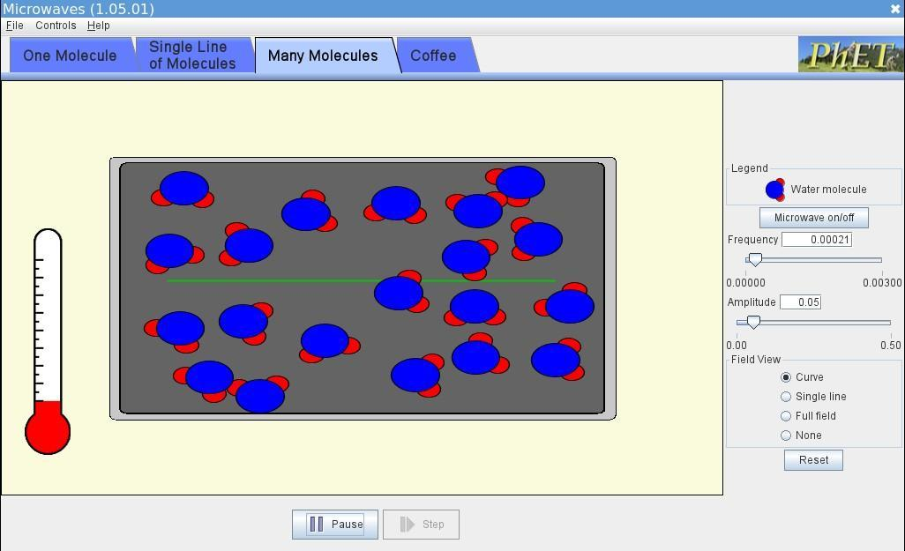

* 1. **High Frequency , Low Amplitude**

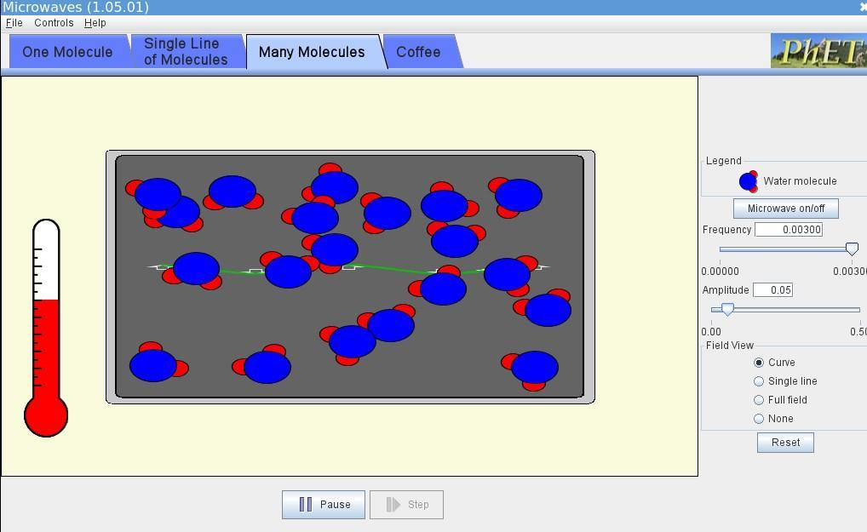

* 1. **Low Frequency , High Amplitude**

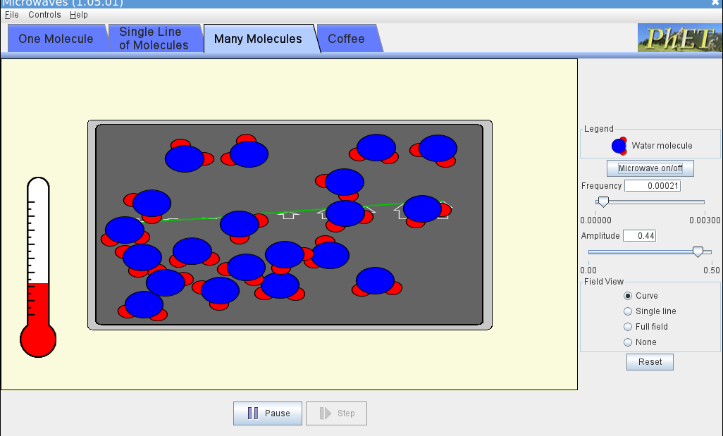

* 1. **High Frequency , High Amplitude**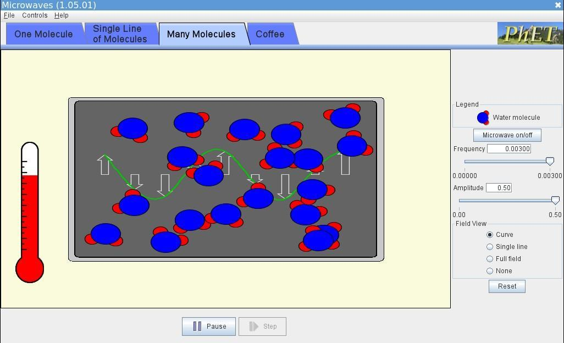

# Coffee

* 1. **Power : 25%**

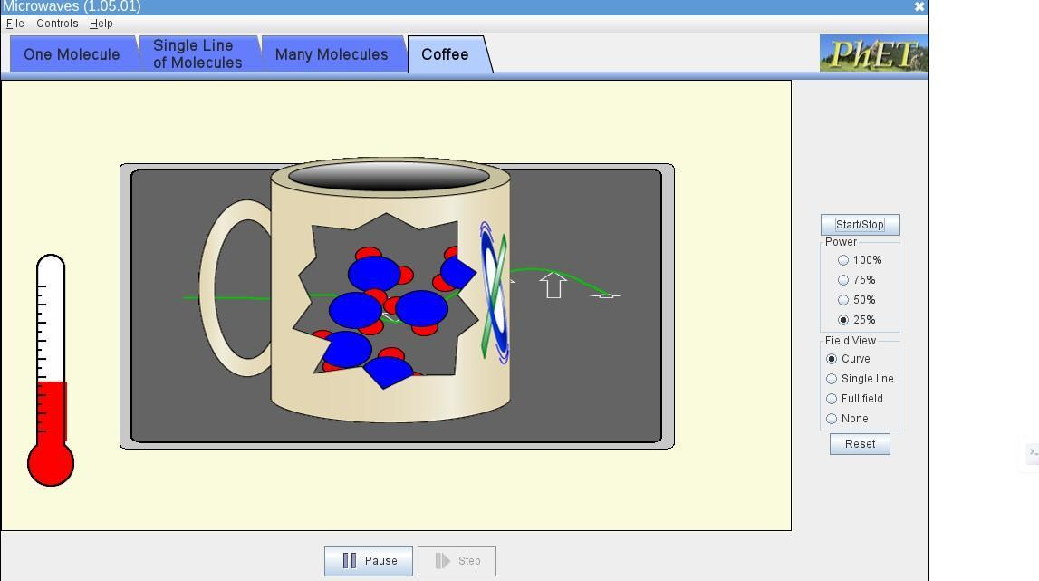

* 1. **Power : 50%**

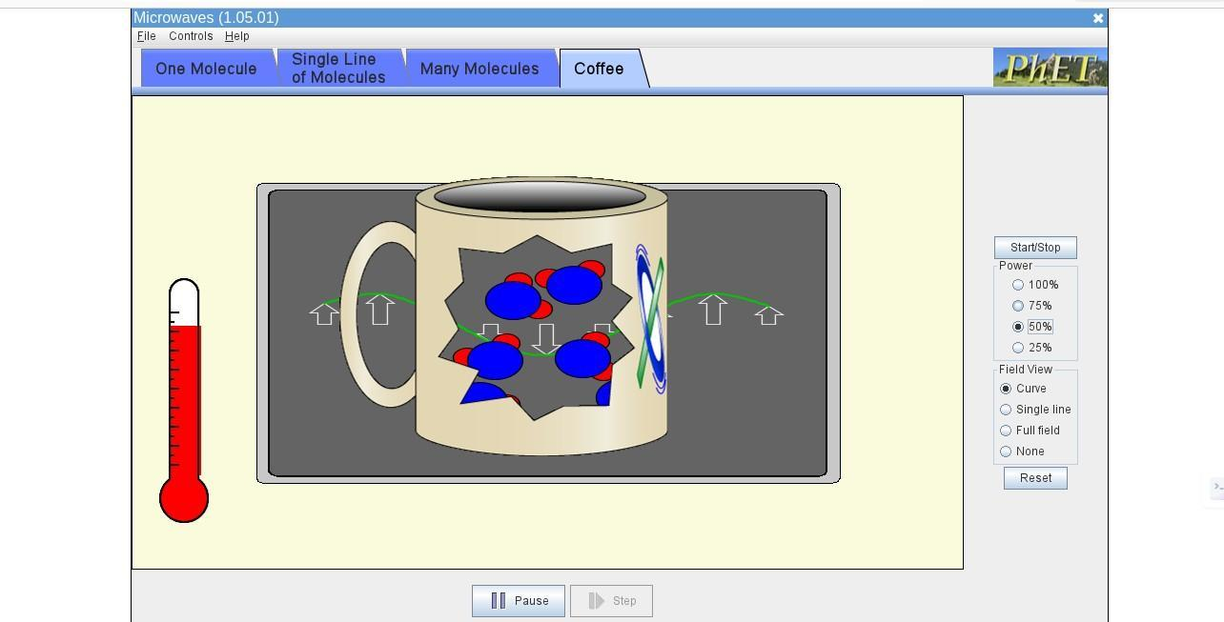

* 1. **Power : 75%**

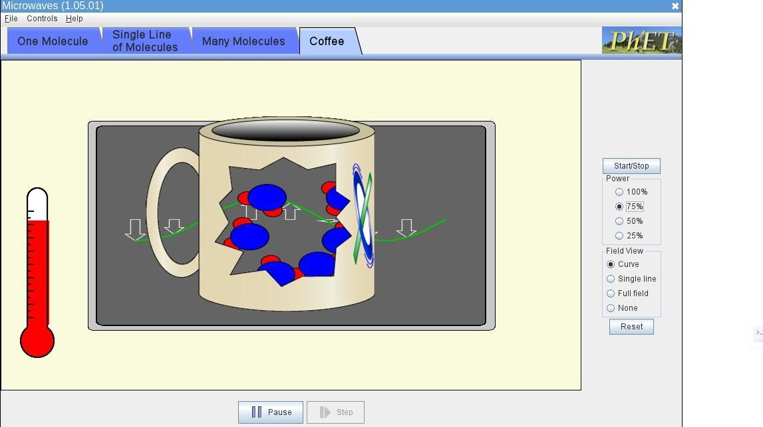

* 1. **Power : 100%**

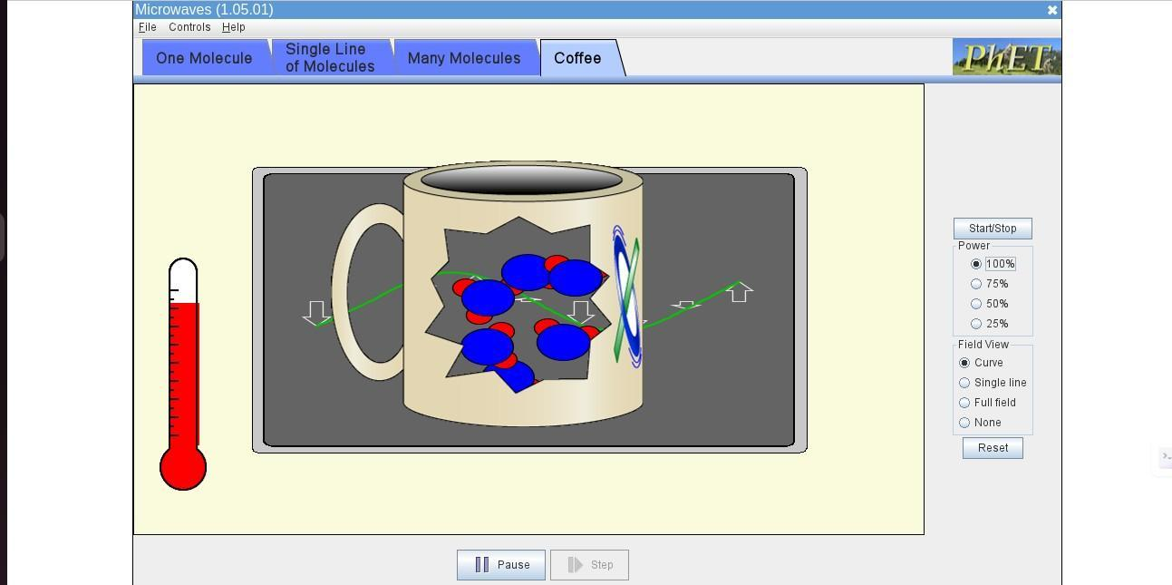

**Conclusion : Microwave power settings (frequency and amplitude) affect how quickly molecules absorb energy and heat up. Lower settings cause minimal energy absorption and a slow temperature rise, while higher settings accelerate energy transfer and temperature increase. The highest power setting results in the most rapid temperature rise, showing maximum energy absorption. This experiment highlights how microwave energy interacts with various molecular systems.**